**Frequently Asked Questions (FAQ)**

Table of Contents

Software Grant Program / Version 3

1. What is the Autodesk Academic Resource Center? 3

2. What versions of software do you provide on ARC portal? 3

3. Where can I get information about the Autodesk product features? 3

Accessibility 3

4. I have not received an email confirming my access after registering on the Autodesk Academic Resource Center website. 3

5. How do I change my email or other contact information in Autodesk Academic Resource Center website? 3

6. My PC is not able to view the screen properly due to poor performance. Therefore I cannot register. Do we require JavaScript enabled? 3

Download 4

7. I’m having problems downloading software. Whom should I contact for assistance? 4

Installation / Deployment 5

8. How do I install and activate software? 5

9. I have problem installing the software in my network. What can I do? 5

10. My download speed is too slow in school. Can I obtain the installation DVDs from you? 6

11. Can I have a hardcopy of the user manual? 6

12. I received the file “ARC-EMS2011enlicense.lic”, what is this for? 6

13. I’ve downloaded a software title from the Autodesk Academic Resource Center but haven’t received a serial number. What should I do? 6

14. Can I install the software using stand-alone or network licensing? 6

15. How many seats can I install using Network Licensing? 6

16. Can you borrow a seat from a server? 7

17. Does Autodesk support ghosting for installation? 7

18. What do I do if I need more than 125 seats? 7

19. What are the system requirements to run Autodesk Education Suite of products? 7

20. How do I look for the server name and Ethernet address for generating network license? 8

Activation 11

21. How do I get activation for my network license server so I can use the software? 11

Software License 12

22. What are the terms of the license? 12

23. What is the type of software offered by Autodesk to institutions for free download and use through The Autodesk Academic Resource Center? 12

24. What configurations of network licensing server are supported? 12

For Personal / Educator Use 13

25. Does Autodesk offer software free of cost to the students and faculty? 13

# Software Grant Program / Version

## What is the Autodesk Academic Resource Center?

Autodesk Academic Resource Center is an online grant delivery program to provide leading design software and technology to education institutions in worldwide emerging markets.

To learn more, visit the [Autodesk Academic Resource Center](http://www.autodesk.com/academic)

## What versions of software do you provide on ARC portal?

Autodesk Academic Resource Center provides the latest version of products and two versions back. Newer versions are made available when they are commercially available.

## Where can I get information about the Autodesk product features?

To learn about what’s new in the latest software releases, visit the product pages at: [Autodesk Products](http://www.autodesk.com/products)

# Accessibility

## ****I have not received an email confirming my access after registering on the Autodesk Academic Resource Center website.****

The most common reason users do not receive the confirmation email is a typo in the email address provided. Please resubmit your registration with careful attention to the spelling of the email address.

If your school email system has strong email SPAM blockers, emails sent from Autodesk may have been rerouted. Check your email filter and talk to your school’s IT department about accepting emails from: “xxx@autodesk.com”.

## ****How do I change my email or other contact information in Autodesk Academic Resource Center website?****

Log on to the Autodesk Academic Resource Center site and go to My Profile to change your data and notifications.

## My PC is not able to view the screen properly due to poor performance. Therefore I cannot register. Do we require JavaScript enabled?

The recommended screen resolution is 1024 x 768 or above to visit The Autodesk Academic Resource Center. A modern browser is required to log on and download from our site, which includes Internet Explorer 7, Mozilla Firefox 3.0 or above, Google Chrome or Safari 4 or above.

# Download

## ****I’m having problems downloading software. Whom should I contact for assistance?****

The files you are downloading are quite large. You may be prompted to install a download manager intended to optimize the download experience. You may also use your own download manager or download accelerator. For download support, please send your queries to our support center in the [Autodesk Academic Resource Center](http://www.autodesk.com/academic)

# Installation / Deployment

## How do I install and activate software?

Follow the instruction steps after logging onto ARC portal; these steps contain detailed instruction to guide you on installation and activation.

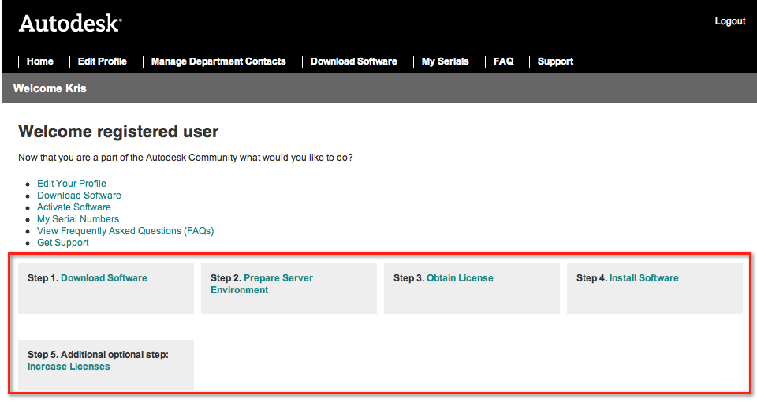

## I have problem installing the software in my network. What can I do?

Refer to the installation and activation related information on this FAQ document and follow the instructions. Refer to the video links provided in the document.

For product installation support, please use the support tab to submit your questions.

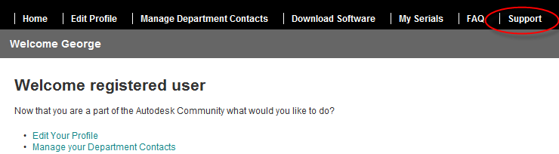

## My download speed is too slow in school. Can I obtain the installation DVDs from you?

The Autodesk Academic Resource Center offers products by download only. Our download tool has the capability of resuming file transferring from the position it stopped last time thus you don’t need to worry about restarting download all over again if you need to disconnect your network before the download completes.

## Can I have a hardcopy of the user manual?

For the consideration of a more sustainable environment, Autodesk does not produce hardcopy installation manuals; however, an online version is available at <http://usa.autodesk.com/support/>

This online document is more user-friendly since it is frequently updated and search-enabled.

## I received the file “ARC-EMS2011enlicense.lic”, what is this for?

This is the network license activation file for your product(s), you need to configure the Network License Manager to work with this file. Instructions can be found at <http://docs.autodesk.com/ACD/2011/ENU/filesLIC/WSfacf1429558a55de6d0beb1006696e53b-7cf2.htm>

## I’ve downloaded a software title from the Autodesk Academic Resource Center but haven’t received a serial number. What should I do?

Your serial number is available on the Autodesk Academic Resource Center site in your profile (click on My Serials) and is also sent to you via email after download.

## Can I install the software using stand-alone or network licensing?

The software offered by Autodesk Academic Resource Center is only available utilizing Autodesk network licensing.

* For more information on network licensing please visit: [Autodesk Licensing, Registration & Activation](http://usa.autodesk.com/adsk/servlet/index?siteID=123112&id=4793616)

Please note that Sketchbook Pro is not available using network licensing and will be delivered using standalone licensing only.

* For installation requirements and instruction videos please visit: [Autodesk Services & Suppor](http://usa.autodesk.com/adsk/servlet/pc/index?id=15115152&siteID=123112)t
* For additional support please visit: [AutoCAD Services & Support](http://usa.autodesk.com/getdoc/id=TS15768659)

## How many seats can I install using Network Licensing?

You may install all applications, one application, or any combination of the applications in the suite on an unlimited number of computers up to number of licenses purchased. As soon as one application is launched, it will request a license from the network licensing server and if there are licenses available (up to 125 concurrent users), that user will receive a license, and the number of available licenses is decremented. This means that you can simultaneously operate 125 licenses of AutoCAD software on 125 computers. Or you could operate 80 licenses of AutoCAD and 45 licenses of Autodesk Inventor software concurrently. The customer cannot run any more than 125 concurrent computers with any application in the suite. Once the server has granted all 125 licenses, the customer will not be able to run any other application until a current user exits the application and returns a license to the network server pool.

## Can you borrow a seat from a server?

If the license pack is deployed using network licensing, it is possible, where available support for such is provided by the individual product, to borrow a license from the available seats for a specific user-designated period of time (maximum of six months). Borrowing licenses in this manner allows the license to continue to operate off the school’s network, but that license will not be available again to other users until the time period for borrowing has expired.

## Does Autodesk support ghosting for installation?

While the online Installation Guide documents a procedure for installing the Education Suites using Symantec™ Ghost™ Solution Suite 2.5, it is provided for informational purposes only and is not officially supported.

## What do I do if I need more than 125 seats?

All software made available by Autodesk Academic Resource Center is configured with a total of 125 seats.

Request for additional seats will be considered only for exceptional cases and upon review. If additional seats are required, please log on to Autodesk Academic Resource Center, and follow *Step 4: additional optional step: Increase Licenses* on the homepage of the site after you login. Refer to screenshot on FAQ #8.

## What are the system requirements to run Autodesk Education Suite of products?

The following system requirements for Autodesk Education Suites are based on the assumption that all applications in the suites would be installed on a computer. Customers who elect to install fewer than the full set of products in a suite may be able to determine less stringent requirements by checking the individual requirements for the products to be installed on the product pages at [Autodesk Products](http://www.autodesk.com/products).

Minimum System Requirements

* **OS:** Windows® XP Professional with Service Pack 2 32-bit
* Browser Microsoft® Internet Explorer® 7.0 (or higher)
* Processor
* Intel® Pentium® 4 processor or AMD Athlon®, 3 GHz or greater
* Intel or AMD Dual Core processor, 1.6 GHz or greater
* RAM 3 GB RAM
* Display 1280 x 1024 32-bit color video display adapter
* 512MB Graphics memory
* DirectX® 9.0c API-capable graphics card supporting Pixel Shader 2.0 or greater
* OpenGL® 2.0 specification support
* Disk Space 2500 GB or larger 7200 RPM hard drive
* Mouse Microsoft Mouse-compliant pointing device with 3 buttons
* Install Media DVD for installation

Recommended System Requirements

* OS:
  + Windows® XP Professional with Service Pack 2
  + Windows XP Professional x64 Edition
  + Windows Vista® 32-bit or 64-bit with SP1 (Business, Premium and Ultimate)
  + Windows 7 (Home, Professional and Ultimate)
* Browser Microsoft® Internet Explorer® 7.0 (or higher)
* Processor Intel or AMD Dual Core processor, 2.4 GHz or greater
* RAM 4 GB RAM
* Display 1600 x 1200 32-bit color video display adapter
* 512MB Graphics memory
* DirectX® 9.0c API-capable graphics card supporting Pixel Shader 2.0 or greater
* OpenGL® 2.0 specification support
* Disk Space 1000 GB or larger 7200 RPM hard drive
* Mouse Microsoft Mouse-compliant pointing device with 3 buttons
* Wacom graphics tablet for sketching
* Install Media DVD for installation

## How do I look for the server name and Ethernet address for generating network license?

In order to generate a license file we will need the Host Name & Host ID of the computer(s) to which you are installing the license file.

Physical Address/Host ID/MAC Address or Ethernet Address: XX-XX-XX-XX-XX-XX is 12 characters long, and can only be a combination of numeric values 0 through 9 and alpha characters A through F).

Please scroll to one of the selection depending on the system where you will be pasting the license file.

*(A) Host Name and ID for Windows*

*(B) Host Name and ID using lmtools.exe*

*(C) Host Name and ID using the Mac OS X or Linux terminal window*

(A) Host Name and ID for Windows

1. Do one of the following:

* (Windows XP) Click Start ➤Programs ➤ Accessories ➤ Command Prompt.
* (Windows Vista) Click Start ➤ All Programs ➤ Accessories ➤ Command Prompt.

2. At the Windows command prompt, enter the following command, and then press

ENTER: ipconfig /all

3. Locate the Host Name line, and write down the host name.

4. Locate the Physical Address line. Write down the physical address without the dashes. This is your twelve-character host ID.

(NOTE: If your server has more than one network adapter, select the one that corresponds to a physical network adapter. To determine which adapters are physical: in the Windows command prompt, enter ipconfig /all, and then view the Description field above each physical address. If there is more than one physical network adapter, it does not matter which one you use. Devices such as VPN adapters, PPP adapters, and modems are not valid).

5. Close the Windows command prompt.

(B) Host Name and ID using lmtools.exe

You should be logged in with Administrator rights when working with the LMTOOLS utility.

6. Do one of the following:

* (Windows XP) Click Start ➤ Programs ➤ Autodesk ➤ Network License Manager ➤ LMTOOLS.
* (Windows Vista) Double-click the LMTOOLS icon on the desktop.

7. In the LMTOOLS program, click the Systems Settings tab.

8. On the Systems Settings tab, locate the Computer/Hostname box. Copy the host name and paste the information into a text editor.

9. Locate the Ethernet Address box. The Ethernet address is the host ID. It consists of twelve characters. Write down the information. If your Ethernet address is more than twelve characters, write down the first twelve characters only.

NOTE: If your server has more than one Ethernet adapter, select one that corresponds to a physical network adapter.

10. Close lmtools.exe.

(C) Host Name and ID using the Mac OS X or Linux terminal window

11. Launch a Terminal window.

12. Go to the directory where lmutil is installed.

13. Retrieve the host name by entering the following in Terminal: ./lmutil lmhostid -hostname

The host name is displayed.

14. Retrieve the host ID by entering the following in Terminal: ./lmutil lmhostid

The twelve-character host ID is displayed.

15. Close the Terminal Window.

# Activation

## How do I get activation for my network license server so I can use the software?

You can register and activate your network license by following the on-screen instructions and submit request to the activation email address provided.

Autodesk uses the network license server host name, host ID, and product serial number to generate a license file. All this information will be required in order to receive activation.

You can also register and activate your software online through Autodesk e-registration. You need to create a new Autodesk User ID and password for software activation. Your ARC username and password is different from the username and password required for activation.

For e-registration and activation of your software please visit:

[Autodesk RegisterOnce.](https://registeronce.autodesk.com)

# Software License

## What are the terms of the license?

Autodesk products are governed by the terms of the software license agreement that appears when installing the software, including the Educational Institutional Version terms of the license agreement. Suites are not licensed to be used for commercial, professional, commercial training, or other for-profit purposes. Autodesk software license agreements can be found online at [Autodesk Legal Notices & Trademarks.](http://www.autodesk.com/eula)

## What is the type of software offered by Autodesk to institutions for free download and use through The Autodesk Academic Resource Center?

The software offered by Autodesk Academic Resource Center is 125 users, Network license with 3 years validity.

## What configurations of network licensing server are supported?

The Autodesk Education Suites support three types of network licensing:

* Single network licensing server
* Distributed network licensing servers
* Redundant network licensing servers

For more information on licensing options, visit: [Autodesk Licensing, Registration & Activation](http://usa.autodesk.com/adsk/servlet/index?siteID=123112&id=4793616)

# For Personal / Educator Use

## Does Autodesk offer software free of cost to the students and faculty?

Yes. Students and faculty may visit the [Autodesk Education Community](http://autodesk.com/edcommunity) to sign up and download more than two dozen Autodesk software titles. Or simply “Like” us in our [Autodesk Facebook Student Page](http://www.facebook.com/autodeskedcommunity) and you may download the software immediately.